horizontal line

EZONE BUILDING ENERGY MANAGEMENT SYSTEM

User Manual

**30th May 2021**

**Project Team**

|  |  |
| --- | --- |
| **Name** | **Student Number** |
| Jason Chu | 21300674 |
| Lifsania Francis Xavier Robin | 22873367 |
| Willem Meyer | 21496322 |
| Yiwen Li | 22061312 |

## 

1.0 Introduction 2

1.1 About the Ezone Building Energy Management System 2

2.0 Users 2

3.0 Admin 3

3.1 Configuring the system: 3

3.2 Collecting the Data 6

## 1.0 Introduction

EZONE Building Energy Management (EBEM) System is a web-based energy information system. Contained herein are the functional requirements and technical specifications for the development of EBEM as well as the project plan outlining development processes, timelines, and milestones.

Over the last 20 years, the University of Western Australia (UWA) has undertaken several commercial and research projects to facilitate the transition towards environmentally sustainable energy generation and consumption. These projects generate a wealth of data that is of interest to a wide variety of people, including UWA management, researchers, government departments and the public. Prompted by UWA’s growing renewable energy portfolio, the EBEM project aims to provide analytical tools for renewable project stakeholders and to promote these projects to the broader UWA community. EBEM will store, transform, and visualize data from multiple energy initiatives operated by UWA and will emphasise extensibility to accommodate additional projects in the future. EBEM is being developed on behalf of Project Sponsor, Prof. Thomas Bräunl as part of the Software Engineering Design Project unit at UWA.

### 1.1 About the Ezone Building Energy Management System

The EBEM System allows users to read energy input and usage from devices on and off the UWA campus that can facilitate visual understanding of the energy expenditure and generation of the EZONE Building and UWA Campus. It acts as a collective hub that represents the cumulative flow of energy usage across all desired devices. This project implements a visual information system that collects data from various energy devices through an easy to implement data collection and transforms the data to visualize it on a publicly available webpage. A key feature of the system is the ability to add new (or existing) energy expenditure/generation devices that can be simply mapped to the system to expand the coverage of devices and energy flow as desired. The visual layer has a large level of viewing ranges from visual graphs to wing ranges from

## 2.0 Users

(to be completed by Willem)

## 3.0 Admin

The admin panel is accessible through the following url: <http://robotics.ee.uwa.edu.au/telemetry/ems/index.php>

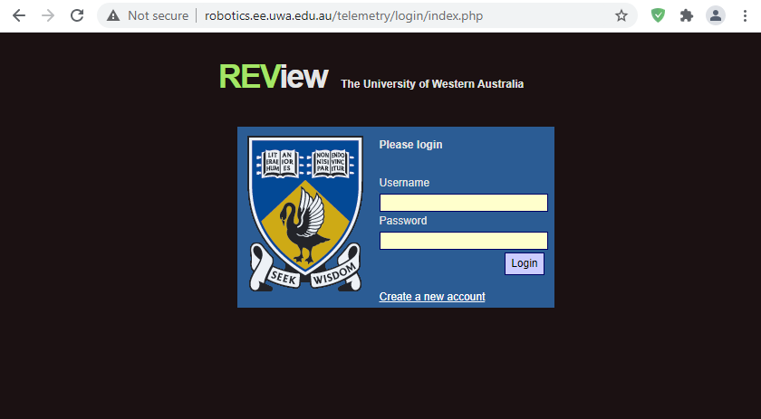

This portal also allows a user to create a new account.

### 3.1 Configuring the system:

After a successful login, the admin is taken to the system configuration page.

**Device operations**:

After navigating to the configuration portal, admins can now edit/delete existing devices or add a new device in the system. A new device can be added by entering the “Device Name” and “System Name” in field and then click the “Save” button. The admin can choose to “Edit” or “Delete” and existing system though the action buttons provided for each device.

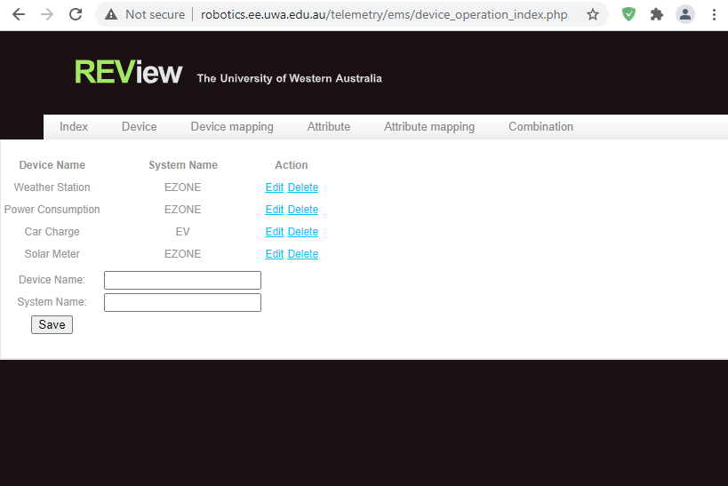

**Device mapping**:

The admin can configure the devices with the appropriate systems by choosing the system names available in the dropdown list. A new device mapping can be added by entering the “External Device Name” and choosing the relevant device ID from the “Device ID” dropdown menu and then click the “Save” button. The admin can choose to “Edit” or “Delete” and existing device mapping though the action buttons provided for each device.

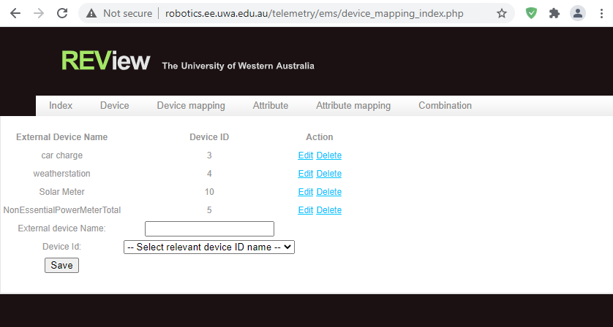

**Attribute operations:**

Similarly, the same actions can be done for attribute in the system as well. A new attribute can be added by entering the “Attribute Name” and “Unit” in field and then click the “Save” button. The admin can choose to “Edit” or “Delete” and existing attributes though the action buttons provided for each device.

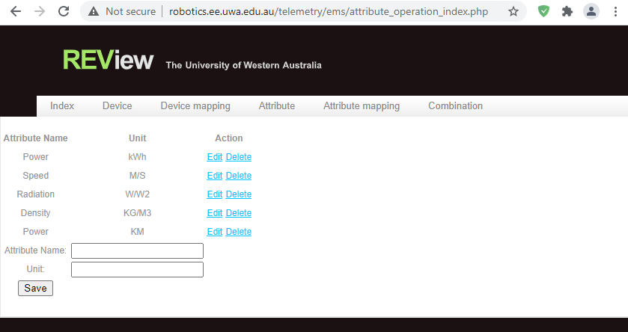

**Attribute mapping:**

Similarly, as the device mapping configuration, the admin can configure the attributes with the appropriate systems by choosing the names available in the dropdown list. A new attribute mapping can be added by entering the “External Attribute Name” and choosing the relevant attribute ID from the “Attribute ID” dropdown menu and then click the “Save” button. The admin can choose to “Edit” or “Delete” and existing attribute mapping though the action buttons provided for each device.

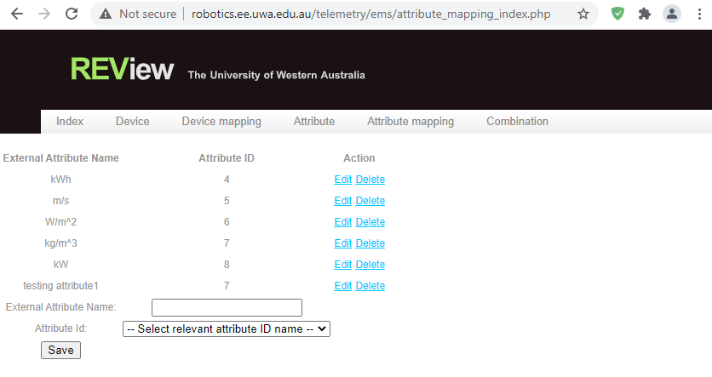

**Device-attribute combination configuration:**

The admins can match the device with it’s appropriate attribute by choosing the device and attribute names available from the drop down list. A new combination can be added by choosing the “Device Name” and the “Attribute Name” from the dropdown menu and then click the “Save” button. The admin can choose to “Edit” or “Delete” and existing combinations though the action buttons provided for each combination in the system.

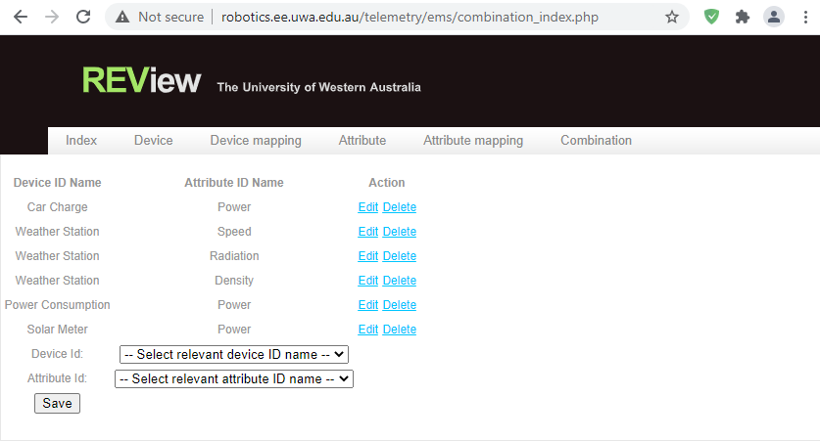

### 3.2 Cron job

The energy device data will be collected every 5 minutes automatically by the Cron job in the Bluehost server. The second Cron job in below list is to reset the access token for the API every 12 hours as the token get expired every 24 hours. And the third Cron job is to execute the data collector in the system to fetch the data form the APIs and save into the database every 5 minutes.

### 3.3 Collecting the Data

The EBEM System is designed strictly with no specific device or device type in mind and supports a large range of readable energy devices. Once the

The EBEM System is designed strictly with no specific device or device type in mind and supports a large range of readable energy devices. Once the user has shaped the existing data from a desired energy device into the suitable format, the system will support a perpetual flow of data information supplied by the energy device. The supplemented data can then be visualised on the public page.

Data collection is to be handled by the external transaction table within the database system. It offers open customisation for the requested data type and translation.

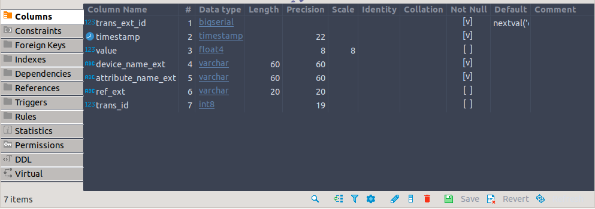

The required columns are as follows:

**timestamp** (*timestamp*): The relevant values timestamp in timestamp format

**value** (*float4*): The numerical value of the data to be input.

**device_name_ext** (*varchar60*): The name representing the device the data originated.

**attribute_name_ext** (*varchar60*): The data’s unit of measurement.

Other columns include :

**trans_ext_id** (*bigserial*): The external transaction ID for database management

**trans_id** *(int8):* The internal transaction ID for database management

**ref_ext** *(varchar*): An optional reference ID for user transaction tracking

Datasets that are to be added into the database must conform to the required columns. That is – a timestamp, the numerical value, a pre-mapped name, and unit of measurement. This ensures that all data in the database can be faultlessly transformed into a visual format.